**POLAR PLOT**

Polar plot is a technique to design a plot of magnitude versus phase angle of sinusoidal transfer function G(jw) as w varies from 0 to ∞.

Polar plot is used for analysis and design of feedback control system by means of Nyquist criterion of complex signal (a + jb)

$$Example:Draw the polar plot of G\left(s\right)=\frac{1}{1+sT}$$

**SOLUTION**

$$G\left(s\right)=\frac{1}{1+sT}----(1)$$

**STEP-I: Put s = j ω in Equation (1)**

$$G\left(jω\right)=\frac{1}{1+jωT}$$

**STEP-II: Find the Magnitude and Phase angle of $G\left(jω\right)$**

$$Magnitude of \left|G\left(jω\right)\right|=\frac{\sqrt{Numerator}}{\sqrt{Denominator}}=\frac{\sqrt{{(1)}^{2}+ {(0)}^{2} }}{\sqrt{{(1)}^{2}+ {(ωT)}^{2}}} =\frac{1}{\sqrt{1+ ω^{2}T^{2}}}$$

$$Phase Angle of G\left(jω\right)=\frac{\tan^{-1}\left(\frac{0}{1}\right)}{\tan^{-1}\left(\frac{ωT}{1}\right)}=\frac{\tan^{-1}\left(0\right)}{\tan^{-1}\left(ωT\right)}= \tan^{-1}\left(0\right)-\tan^{-1}\left(ωT\right)=0- \tan^{-1}\left(ωT\right)= -\tan^{-1}\left(ωT\right)$$

**STEP-III: Put the limit $ω→0 and ω→∞$ in Magnitude and Phase angle of $G\left(jω\right)$**

$$\lim_{ω→0}$$

$$Magnitude of \left|G\left(jω\right)\right|=\frac{1}{\sqrt{1+ ω^{2}T^{2}}}=\frac{1}{\sqrt{1+ {(0)}^{2}T^{2}}}=\frac{1}{\sqrt{1+ 0}}=1$$

$$Phase Angle of G\left(jω\right)=-\tan^{-1}\left(ωT\right)= - \tan^{-1}\left(0*T\right)=-\tan^{-1}\left(0\right)= 0^{0}$$

$$\lim_{ω→∞}$$

$$Magnitude of \left|G\left(jω\right)\right|=\frac{1}{\sqrt{1+ ω^{2}T^{2}}}=\frac{1}{\sqrt{1+ {(∞)}^{2}T^{2}}}=\frac{1}{\sqrt{1+ ∞}}=\frac{1}{\sqrt{ ∞}}=\frac{1}{∞}=0$$

$$Phase Angle of G\left(jω\right)=-\tan^{-1}\left(ωT\right)= - \tan^{-1}\left(∞*T\right)=-\tan^{-1}\left(∞\right)= {-90}^{0}$$

**STEP-IV: Draw Polar Plot**

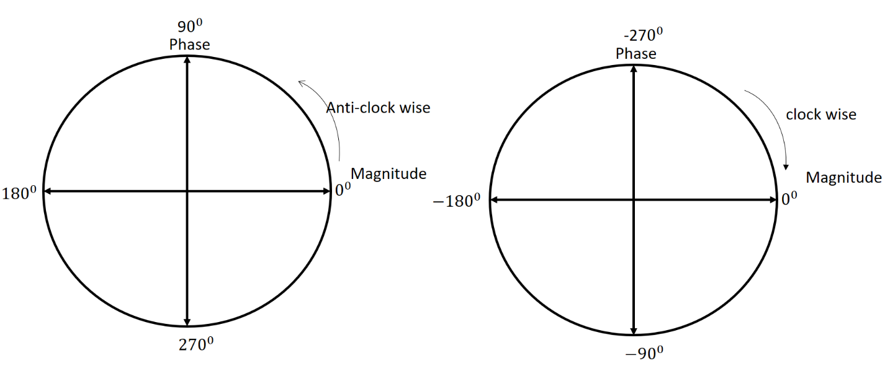

$$at ω →0$$

$$Magnitude of \left|G\left(jω\right)\right|=1$$

$$Phase Angle of G\left(jω\right)= 0^{0}$$

$$at ω →∞$$

$$Magnitude of \left|G\left(jω\right)\right|=0$$

$$Phase Angle of G\left(jω\right)= {-90}^{0}$$

***Now we plotting of only $ω$***

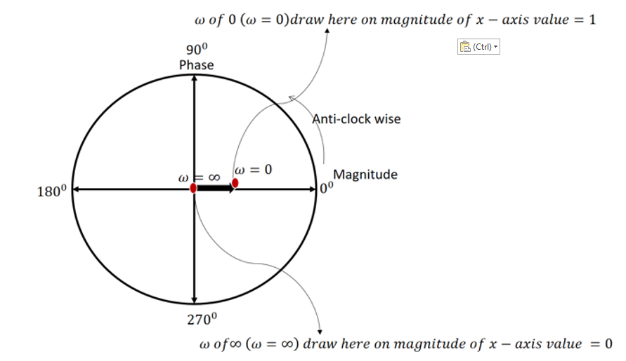

***Now we Draw curves with the help of angle***

$ω$ equal to zero then its angle is zero , we connect through one straight line

$And ω$ equal to infinity then its angle is -900 , we connect through one curve line

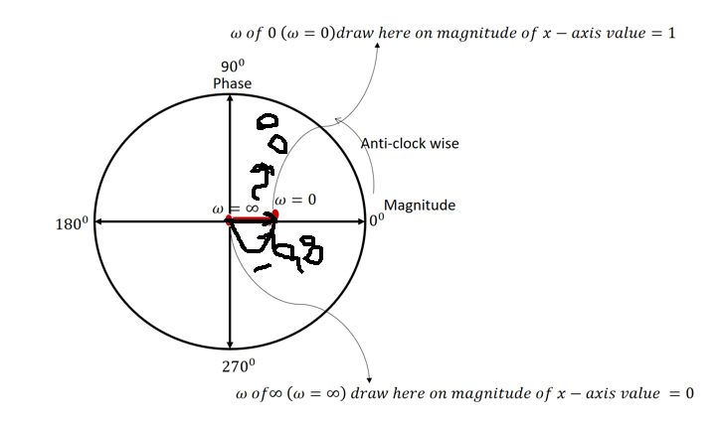

$$Example:Draw the polar plot of G\left(s\right)=\frac{1}{(1+sT_{1})(1+sT_{2})(1+sT_{3})}$$

**SOLUTION**

$$G\left(s\right)=\frac{1}{(1+sT_{1})(1+sT_{2})(1+sT_{3})}----(1)$$

**STEP-I: Put s = j ω in Equation (1)**

$$G\left(jω\right)=\frac{1}{(1+jωT_{1})(1+jωT_{2})(1+jωT_{3})}$$

**STEP-II: Find the Magnitude and Phase angle of**

*In case of angle multiplication can be changed into addition*

Angle in division change into subtraction

**STEP-III: Put the limit in Magnitude and Phase angle of**

**STEP-IV: Draw Polar Plot**

***Now we plotting of only and also draw curves with the help of angle***

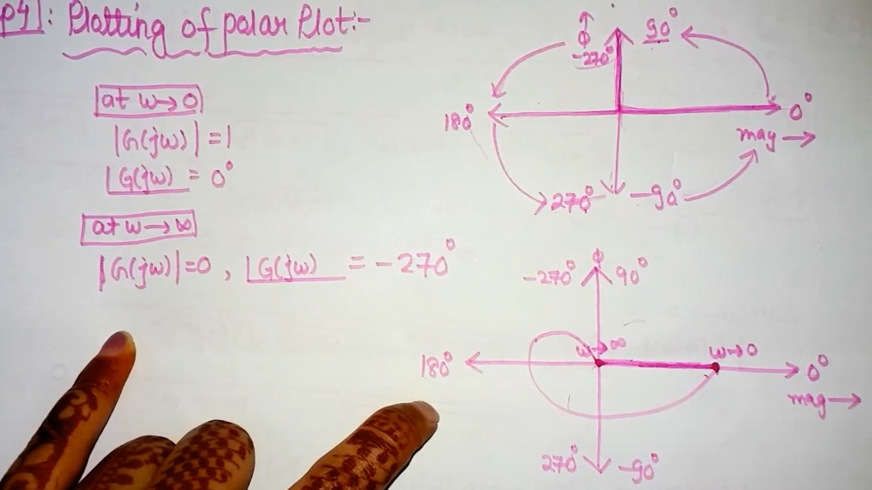

$$Example:Draw the polar plot, whose open loop transfer function is given by$$

$$G\left(s\right)H(s)=\frac{50}{(s+1)(s+2)}$$

**SOLUTION**

$$G\left(s\right)H(s)=\frac{50}{(s+1)(s+2)}----(1)$$

**STEP-I: Put s = j ω in Equation (1)**

$$G\left(jω\right)H(jω)=\frac{50}{(jω+1)(jω+2)}$$

**STEP-II: Find the Magnitude and Phase angle of $G\left(jω\right)$**

$$Magnitude of \left|G\left(jω\right)\right|=\frac{\sqrt{Numerator}}{\sqrt{Denominator}}=\frac{\sqrt{{(50)}^{2}+ {(0)}^{2} }}{\sqrt{{(1)}^{2}+ {(ω)}^{2}} .\sqrt{{(2)}^{2}+ {(ω)}^{2}}}$$

$$Magnitude of \left|G\left(jω\right)\right|=\frac{50}{\sqrt{1+ ω^{2}} .\sqrt{4+ ω^{2}}}$$

$$Phase Angle of G\left(jω\right)=\frac{\tan^{-1}\left(\frac{0}{50}\right)}{\tan^{-1}\left(\frac{ω}{1}\right).\tan^{-1}\left(\frac{ω}{2}\right)}=\frac{\tan^{-1}\left(0\right)}{\tan^{-1}\left(ω\right).\tan^{-1}\left(\frac{ω}{2}\right)}$$

*In case of angle multiplication can be changed into addition*

Angle in division change into subtraction

**STEP-III: Put the limit in Magnitude and Phase angle of**

**STEP-IV: Draw Polar Plot**

***Now we plotting of only and, also draw curves with the help of angle***

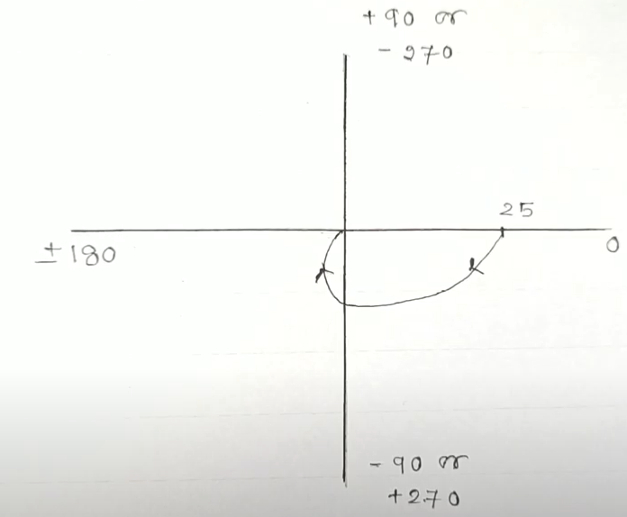

$$Example:Draw the polar plot, whose open loop transfer function is given by$$

$$G\left(s\right)H(s)=\frac{10}{(s+2)}$$

**SOLUTION**

$$G\left(s\right)H(s)=\frac{10}{(s+2)}----(1)$$

**STEP-I: Put s = j ω in Equation (1)**

$$G\left(jω\right)H(jω)=\frac{10}{(jω+2)}$$

**STEP-II: Find the Magnitude and Phase angle of $G\left(jω\right)$**

$$Magnitude of \left|G\left(jω\right)\right|=\frac{\sqrt{Numerator}}{\sqrt{Denominator}}=\frac{\sqrt{{(10)}^{2}+ {(0)}^{2} }}{\sqrt{{(2)}^{2}+ {(ω)}^{2}} }$$

$$Magnitude of \left|G\left(jω\right)\right|=\frac{10}{\sqrt{4+ ω^{2}} }$$

$$Phase Angle of G\left(jω\right)=\frac{\tan^{-1}\left(\frac{0}{10}\right)}{\tan^{-1}\left(\frac{ω}{2}\right)}=\frac{\tan^{-1}\left(0\right)}{\tan^{-1}\left(\frac{ω}{2}\right)}$$

Angle in division change into subtraction

$$Phase Angle of G\left(jω\right)= \tan^{-1}\left(0\right)-\left\{\tan^{-1}\left(\frac{ω}{2}\right)\right\}$$

$$Phase Angle of G\left(jω\right)= \tan^{-1}\left(0\right)-\tan^{-1}\left(\frac{ω}{2}\right)$$

$$Phase Angle of G\left(jω\right)= 0^{0}-\tan^{-1}\left(\frac{ω}{2}\right)$$

$$Phase Angle of G\left(jω\right)= -\tan^{-1}\left(\frac{ω}{2}\right)$$

**STEP-III: Put the limit $ω→0 and ω→∞$ in Magnitude and Phase angle of $G\left(jω\right)$**

$$\lim_{ω→0}$$

$$Magnitude of \left|G\left(jω\right)\right|=\frac{10}{\sqrt{4+ ω^{2}} }$$

$$Magnitude of \left|G\left(jω\right)\right|=\frac{10}{\sqrt{4+ 0^{2}} }$$

$$Magnitude of \left|G\left(jω\right)\right|=\frac{10}{\sqrt{4} }$$

$$Magnitude of \left|G\left(jω\right)\right|=\frac{10}{2 }=5$$

$$Phase Angle of G\left(jω\right)= -\tan^{-1}\left(\frac{ω}{2}\right)$$

$$Phase Angle of G\left(jω\right)= -\tan^{-1}\left(\frac{0}{2}\right)$$

$$Phase Angle of G\left(jω\right)= -\tan^{-1}\left(0\right)$$

$$Phase Angle of G\left(jω\right)= 0$$

$$\lim_{ω→∞}$$

$$Magnitude of \left|G\left(jω\right)\right|=\frac{10}{\sqrt{4+ ω^{2}} }$$

$$Magnitude of \left|G\left(jω\right)\right|=\frac{10}{\sqrt{4+ ∞^{2}} }$$

$$Magnitude of \left|G\left(jω\right)\right|=\frac{10}{\sqrt{ ∞^{2}} }$$

$$Magnitude of \left|G\left(jω\right)\right|=\frac{10}{ ∞}$$

$$Magnitude of \left|G\left(jω\right)\right|=0$$

$$Phase Angle of G\left(jω\right)= -\tan^{-1}\left(\frac{ω}{2}\right)$$

$$Phase Angle of G\left(jω\right)= -\tan^{-1}\left(\frac{∞}{2}\right)$$

$$Phase Angle of G\left(jω\right)= -\tan^{-1}\left(∞\right)$$

$$Phase Angle of G\left(jω\right)= -{90}^{0}$$

**STEP-IV: Draw Polar Plot**

***Now we plotting of only and, also draw curves with the help of angle***

